🧩 Client Case — Beijing LN New Energy Co., Ltd.
YUEDU SL800 Carbon Fiber Explosion-Proof Sealed Shredding System
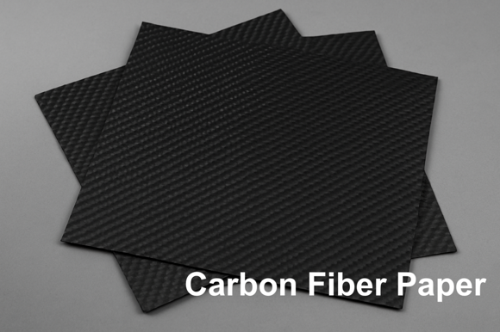 | 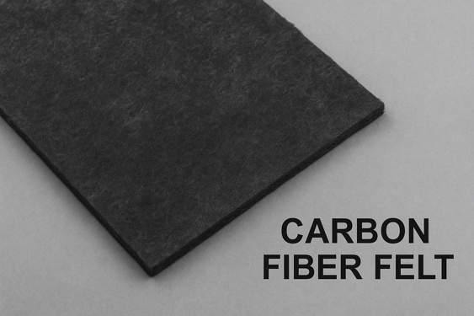
Carbon Fiber Paper（碳纤维纸） | Carbon Fiber Felt（碳纤维毡）

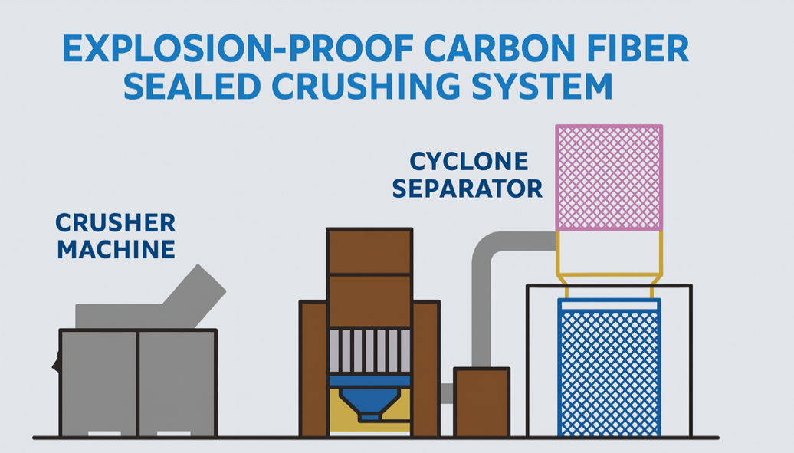
🧭 Explosion-Proof Sealed Carbon Fiber Shredding System — Confidential Schematic

1. Company Background
LN New Energy focuses on R&D and manufacturing of new-energy application materials, tackling bottleneck core materials in the hydrogen energy industry. Its carbon fiber paper and felt are used in hydrogen energy, energy storage, and high-performance composites. The team has achieved end-to-end breakthroughs in carbon-fiber application materials and notable results in GDL manufacturing and fuel-cell components.

2. Customer Requirements (Summary)
- Solution: Carbon-fiber shredder / explosion-proof sealed shredding system
- Materials: Carbon Fiber Paper, Carbon Fiber Felt
- Feed width: 1.2 m
- Footprint: ≤ 3 m²
- Special requirements: Dust- and explosion-proof, antistatic, fully sealed; minimize airborne dust; compact/easy maintenance; safe feeding and bagging; IP58 protection level.

3. Customer Pain Points & Technical Challenges

Summary (one-glance view)
Pain Point | YUEDU Solution
Strict particle control; avoid powdering | Innovative shredding approach; precise blade-gap control
Full sealing / dust & explosion-proof | Negative-pressure sealing + explosion-proof motor & fan (ExdⅡBT4)
Dust escape at collection; unsafe for operators | Sealed collection bin + negative-pressure bagging + auto sealing
Conductive dust damages motors/electrics | IP58 protection system + antistatic discharge path

Detailed points (as in the doc)
- Tight particle size (10–20 mm flakes/fibrous), no over-pulverization.
Measures: new structure to avoid high-speed shearing; precise blade gap; anti-recut discharge channel.
- Extreme sealing to prevent dust leakage & health risks.
Measures: fully sealed chamber + dust collection; sealed connections across shredder, fan, cyclone, and filter; all electrics explosion-proof; system protection IP58.
- Unsafe collection if unsealed.
Measures: sealed collection chamber with quick bag change; negative-pressure bagging; optional auto sealing & vacuum.
- Electrical damage risk from conductive carbon fiber dust.
Measures: IP58 explosion-proof design for motor/fan/electrics; antistatic conduits and sealed interfaces; isolated electrical bay with gaskets; dedicated grounding & static discharge path.

4. YUEDU Shredding System Solution
- Model: Customized SL800 Explosion-Proof Sealed Carbon-Fiber Shredding System
- Process flow: Feeding → Shredding → Conveying → Separation → Filtration → Collection
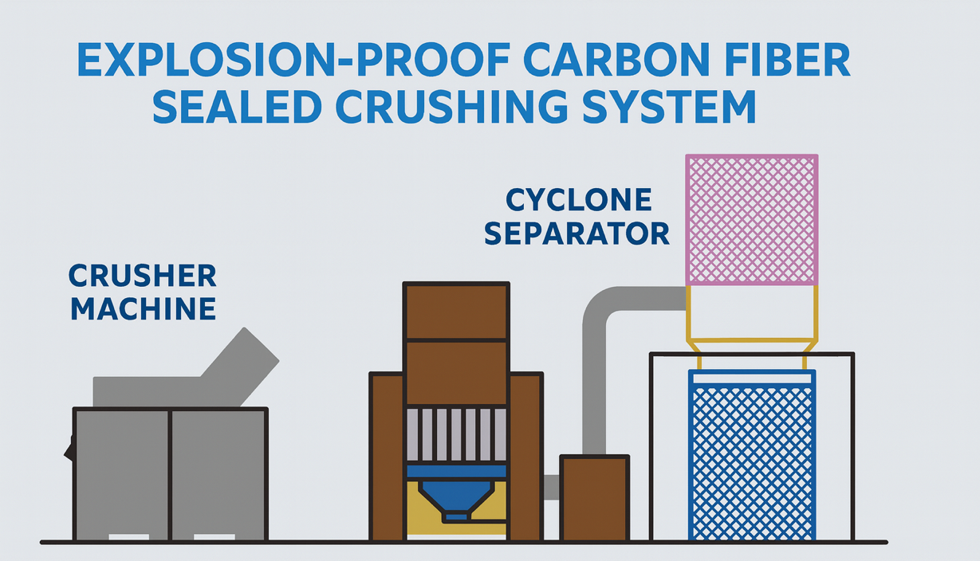
Explosion-Proof Sealed Carbon Fiber Shredding System — Confidential Schematic.

5. System Highlights
- Full sealed structure; dust- & explosion-proof; no leakage.
- Precise particle control, preserving carbon-fiber structure.
- Antistatic discharge design to prevent short circuits.
- Sealed, safe bagging to protect operators.
- Modular for easy install/maintenance; ≤ 3 m² footprint.

6. Quotation & Delivery
- Project: Customized SL800 explosion-proof sealed carbon-fiber shredding system — Qty: 1 set (pricing per commercial quote).
- Lead time: 20–30 working days.
- Includes: factory testing, explosion-proof certification, operation manual.

7. Expected Outcomes
- 10–20 mm particle size with preserved fiber structure.
- Fully sealed & explosion-proof operation; no dust pollution.
- Stable equipment operation; motors/electrics protected from conductive dust.
- Green, low-pollution, high-safety production goals achieved.

🌐 Contact Us
Shanghai YUEDU Technology Co., Ltd.
📞 Contact Us to explore more customized models and tailored shredding solutions that suit your specific needs!
Let us help you find the perfect equipment for your application.
📱 Sales Supervisor: +86 159 0178 2779 (WhatsApp / WeChat / Facebook)
📱 Administrative Supervisor: +86 137 6138 5116
📧 Email: yuedushredders@gmail.com | denghao8410@gmail.com
🌐 Website: www.yuedushredders.com
@YUEDUShredders – Empowering Global Industries with Intelligent Destruction Systems.

